**CS201 – Fall 2019- Sabancı University**

**Homework 3 – String Matching**

**Due November 1, 2019, Friday, 22:00 (Sharp Deadline)**

**Brief Description**

In this homework, you will write a console application that would take two string values as input and search one of them in the other.

The C++ program that you are going to implement will operate based on the selection number input by the user. According to the selection your program will either continue to get more inputs or exit the execution. The input can either be a source string or a search string and your program will search the latter string within the source string. If your program finds the search string in the source string it will output the index where the search string is found and display that index along with the search string to the console (all of the results will be printed out if multiple matches exist). There are some rules for the input strings and selection choices by the user. Details will be explained later in the document.

We will be automatically grading your homework using GradeChecker, so it is very important to satisfy the exact same output given in the sample runs. You can utilize GradeChecker (<http://sky.sabanciuniv.edu:8080/GradeChecker/> ) to check whether your code is working in the expected way. To be able to use GradeChecker, you should upload **ALL** of your (.h and .cpp) files used in the homework. Additionally, you should submit **ALL** of your files to SUCourse **without zipping** them. **Just a reminder, you will see a character ¶ which refers to a newline in your expected output.**

**The name of your main source (cpp) file should be in the expected format:** "sucourseusername_lastname_name_hwnumber.cpp" (all lowercase letters). Please check the submission procedures of the homework in this document.

**To get help using GradeChecker you may ask questions to the list of your grader TAs: cs201gchelp@lists.sabanciuniv.edu**

**NOTE THAT,** we did not upload all of the queries in the sample runs to GradeChecker. So, you may want to check all of queries manually.

**Details and Rules**

First of all, your program will display the possible selections with example source and search strings in the beginning of the program, where there will be three choices. If selection 1 or 2 is input by the user, then you should take the source or search string as input respectively and wait for the next input. If the user enters 3 as the selection, then you should exit and end the program. If the user inputs a wrong selection number, then you should print an error message and continue the program waiting for the next input.

Secondly, when the user inputting the strings or selections you should do various input checks against all possible errors. These will be explained in the following section. Your program should only end if the user enters the selection 3 to exit.

Thirdly, your program will accept strings, that consist of **ONLY** lowercase letters as source string. This rule holds for the search string too except for one character, which is **‘?’**. Your search string may contain the **‘?’ (Question Mark)** character as a wild card, i.e. this character matches **any** character.

Finally, when your program matches the search string in the source, it should print the starting index point of the match and also the matched string.

**Input Entry and Input Check**

* Selection choice MUST be one of **{1, 2, 3}**. Any other digits or strings are invalid input. HINT: You may take choice from user as a string for the sake of simplicity.
* Source string
  + **MUST NOT** be empty
  + **MUST NOT** contain ‘?’
  + **MUST NOT** contain any character except lower case letters ‘a’-‘z’
* Search string
  + **MUST NOT** be empty,
  + **MUST NOT** be longer than the source string,
  + **MUST NOT** contain any character except lower case letters ‘a’-‘z’ and ‘?’
  + **MUST NOT** be **ONLY** ‘?’s

If any of the inputs are not valid, your program should display an error message and expect a new input from the user.

**Use of Functions and Other Rules**

Unlike the second homework, we will not specify any functions here. But you are expected to use functions to avoid code duplication and improve the modularity of your program. **If your main function or any user-defined function is too long and if you do everything in main or in another user-defined function, your grade may be lowered.**

**AND PLEASE DO NOT WRITE EVERYTHING IN MAIN AND THEN TRY TO SPLIT THE TASK INTO SOME FUNCTIONS JUST TO HAVE SOME FUNCTIONS OTHER THAN MAIN. THIS IS TOTALLY AGAINST THE IDEA OF FUNCTIONAL DESIGN AND NOTHING BUT A DIRTY TRICK TO GET SOME POINTS. INSTEAD PLEASE DESIGN YOUR PROGRAM BY CONSIDERING NECESSARY FUNCTIONS AT THE BEGINNING.**

Try to use parametric functions and avoid inputs in functions. Do NOT use any global variables (variables defined outside the functions) to avoid parameter use.

**As in the previous homework, no abrupt program termination is allowed in the middle of the program! The program flow should continue until the end of the main function.**

**Sample Runs**

Below, we provide some sample runs of the program that you will develop.

**NOTE THAT,** we did not upload all of the queries in the sample runs to GradeChecker. So, you may want to check all of queries manually.

**Sample Run 1**

This program searches a search string in a source string with the option of wildcards.

Example inputs with their meaning in parantheses:

1 thislectureisawesome (to enter a new source string)

2 lecture (to enter a new source string)

2 t?r? (to enter a source string with wildcards)

3 (to exit the program)

Enter your choice and string: ***1 changingthesourcestring***

Source word has been changed to "changingthesourcestring"

Enter your choice and string: ***2 the***

For the source word "changingthesourcestring" and search word "the",

"the" has been found at index 8

Enter your choice and string: ***2 ing***

For the source word "changingthesourcestring" and search word "ing",

"ing" has been found at index 5

"ing" has been found at index 20

Enter your choice and string: ***2 i?g***

For the source word "changingthesourcestring" and search word "i?g",

"ing" has been found at index 5

"ing" has been found at index 20

Enter your choice and string: ***2 is***

For the source word "changingthesourcestring" and search word "is", no match has been found.

Enter your choice and string: ***2 ?es***

For the source word "changingthesourcestring" and search word "?es",

"hes" has been found at index 9

"ces" has been found at index 15

Enter your choice and string: ***2 ?e?***

For the source word "changingthesourcestring" and search word "?e?",

"hes" has been found at index 9

"ces" has been found at index 15

Enter your choice and string: ***3***

See you!

**Sample Run 2**

This program searches a search string in a source string with the option of wildcards.

Example inputs with their meaning in parantheses:

1 thislectureisawesome (to enter a new source string)

2 lecture (to enter a new source string)

2 t?r? (to enter a source string with wildcards)

3 (to exit the program)

Enter your choice and string: ***1 newsourcestring***

Source word has been changed to "newsourcestring"

Enter your choice and string: ***1 newsourcestringv2***

Wrong input format! Try again.

Enter your choice and string: ***1 newsourcestringvtwo***

Source word has been changed to "newsourcestringvtwo"

Enter your choice and string: ***2 ?***

Wrong input format! Try again.

Enter your choice and string: ***2 ???***

Wrong input format! Try again.

Enter your choice and string: ***2 erf2***

Wrong input format! Try again.

Enter your choice and string: ***2 sou*ce***

Wrong input format! Try again.

Enter your choice and string: ***2 ?o***

For the source word "newsourcestringvtwo" and search word "?o",

"so" has been found at index 3

"wo" has been found at index 17

Enter your choice and string: ***3***

See you!

**Sample Run 3**

This program searches a search string in a source string with the option of wildcards.

Example inputs with their meaning in parantheses:

1 thislectureisawesome (to enter a new source string)

2 lecture (to enter a new source string)

2 t?r? (to enter a source string with wildcards)

3 (to exit the program)

Enter your choice and string: ***2 sabanci***

Wrong input format! Try again.

Enter your choice and string: ***1 helloworld?***

Wrong input format! Try again.

Enter your choice and string: ***1 thisissourcestring***

Source word has been changed to "thisissourcestring"

Enter your choice and string: ***2 this***

For the source word "thisissourcestring" and search word "this",

"this" has been found at index 0

Enter your choice and string: ***2 ?i?***

For the source word "thisissourcestring" and search word "?i?",

"his" has been found at index 1

"sis" has been found at index 3

"rin" has been found at index 14

Enter your choice and string: ***2 t?***

For the source word "thisissourcestring" and search word "t?",

"th" has been found at index 0

"tr" has been found at index 13

Enter your choice and string: ***2 thisissourcestring***

For the source word "thisissourcestring" and search word "thisissourcestring",

"thisissourcestring" has been found at index 0

Enter your choice and string: ***2 thisissourcestrin?***

For the source word "thisissourcestring" and search word "thisissourcestrin?",

"thisissourcestring" has been found at index 0

Enter your choice and string: ***2 ?hisissourcestrin?***

For the source word "thisissourcestring" and search word "?hisissourcestrin?",

"thisissourcestring" has been found at index 0

Enter your choice and string: ***5***

Choice can be 1, 2 or 3! Try again.

Enter your choice and string: ***Cs201***

Choice can be 1, 2 or 3! Try again.

Enter your choice and string: ***3***

See you!

**Sample Run 4**

This program searches a search string in a source string with the option of wildcards.

Example inputs with their meaning in parantheses:

1 thislectureisawesome (to enter a new source string)

2 lecture (to enter a new source string)

2 t?r? (to enter a source string with wildcards)

3 (to exit the program)

Enter your choice and string: ***1 sabanciuniversity***

Source word has been changed to "sabanciuniversity"

Enter your choice and string: ***2 university***

For the source word "sabanciuniversity" and search word "university",

"university" has been found at index 7

Enter your choice and string: ***2 ab?n***

For the source word "sabanciuniversity" and search word "ab?n",

"aban" has been found at index 1

Enter your choice and string: ***2 uni?er***

For the source word "sabanciuniversity" and search word "uni?er",

"univer" has been found at index 7

Enter your choice and string: ***2 un??er***

For the source word "sabanciuniversity" and search word "un??er",

"univer" has been found at index 7

Enter your choice and string: ***2 u?i?er***

For the source word "sabanciuniversity" and search word "u?i?er",

"univer" has been found at index 7

Enter your choice and string: ***2 s???***

For the source word "sabanciuniversity" and search word "s???",

"saba" has been found at index 0

"sity" has been found at index 13

Enter your choice and string: ***1 university***

Source word has been changed to "university"

Enter your choice and string: ***2 sabanciuniversity***

Wrong input format! Try again.

Enter your choice and string: ***2 university***

For the source word "university" and search word "university",

"university" has been found at index 0

Enter your choice and string: ***3***

See you!

**What and where to submit (PLEASE READ, IMPORTANT)?**

You should prepare (or at least test) your program using MS Visual Studio 2010 C++. We will use the standard C++ compiler and libraries of the abovementioned platform while testing your homework.

It'd be a good idea to write your name and last name in the program (as a comment line of course).

Submissions guidelines are below. Some parts of the grading process are automatic. Students are expected to strictly follow these guidelines in order to have a smooth grading process. If you do not follow these guidelines, depending on the severity of the problem created during the grading process, 5 or more penalty points are to be deducted from the grade.

* Name your cpp file that contains your program as follows.

“**SUCourseUserName_YourLastname_YourName_HWnumber.cpp**”

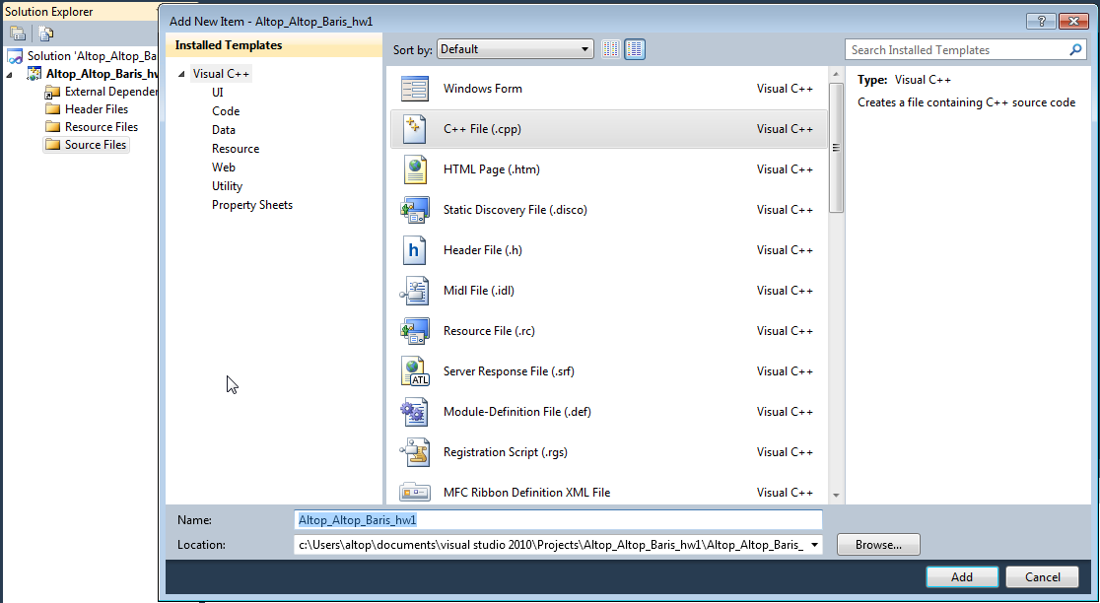

Your SUCourse user name is actually your SUNet user name, which is used for checking sabanciuniv e-mails. Do NOT use any spaces, non-ASCII and Turkish characters in the file name. For example, if your SUCourse user name is cago, name is Çağlayan, and last name is Özbugsızkodyazaroğlu, then the file name must be:

**cago_ozbugsizkodyazaroglu_caglayan_hw3.cpp**

* Do not add any other character or phrase to the file name.
* Make sure that this file is the latest version of your homework program.
* The naming convention of the cpp file is the same as the cpp file (except the extension of the file of course). The name of the cpp file should be as follows.

“**SUCourseUserName_YourLastname_YourName_HWnumber.cpp**”

For example kipler_kipleroglu_zubeyir_hw3.cpp is a valid name, but hw3_hoz_HasanOz.cpp, HasanOzHoz.cpp are NOT valid names.

* Submit via SUCourse ONLY! You will receive no credits if you submit by other means

(e-mail, paper, etc.).

1. Click on "Assignments" at CS201 SUCourse (not the CS201 web site).
2. Click Homework 3 in the assignments list.
3. Click on "Add Attachments" button.
4. Click on "Browse" button and select the cpp file that you generated.
5. Now, you have to see your cpp file in the "Items to attach" list.
6. Click on "Continue" button.
7. Click on "Submit" button. We cannot see your homework if you do not perform this step even if you upload your file.

* After submission, you will be able to take your homework back and resubmit. In order to resubmit, follow the following steps.

1. Click on "Assignments" at CS201 SUCourse.
2. Click Homework 3 in the assignments list.
3. Click on "Re-submit" button.
4. Click on "Add/remove Attachments" button
5. Remove the existing cpp file by clicking on "remove" link. This step is very important. If you do not delete the old cpp file, we receive both files and the old one may be graded.
6. Click on "Browse" button and select the new cpp file that you want to resubmit.
7. Now, you have to see your new cpp file in the "Items to attach" list.
8. Click on "Continue" button.
9. Click on "Submit" button. We cannot see your homework if you do not perform this step even if you upload your file.

**Successful submission is one of the requirements of the homework. If, for some reason, you cannot successfully submit your homework and we cannot grade it, your grade will be 0.**

**General Homework Rules**

* **Having a correct program is necessary, but not sufficient to get the full grade. Comments, indentation, meaningful and understandable identifier names, informative introduction and prompts, and especially proper use of required functions, unnecessarily long program (which is bad) and unnecessary code duplications (which is also bad) will also affect your grade.**
* Please submit your own work only (even if it is not working). It is really easy to find out “similar” programs!
* For detailed rules and course policy on plagiarism, please check out <http://myweb.sabanciuniv.edu/gulsend/su_current_courses/cs-201-spring-2008/plagiarism/>

and keep in mind that

**Plagiarism will not be tolerated!**

Good Luck!

Hanefi Mercan and Gulsen Demiroz